**Carson Lampila Project 3 Proposals**

1) Growth of U.S. Internet Usage

This service allows users to search for the presence of Internet services within households from the state level to the county level. The user will be able to search by specific state or county to find the current and former statistics, along with growth over a selected period of time. In addition, the user will be able to toggle between how much of the population has access to Internet access within the household and those who do not.

2)

Mapbox API:

<https://account.mapbox.com/>

U.S. Census Data

<https://www.census.gov/programs-surveys/acs/guidance/estimates.html>

3)

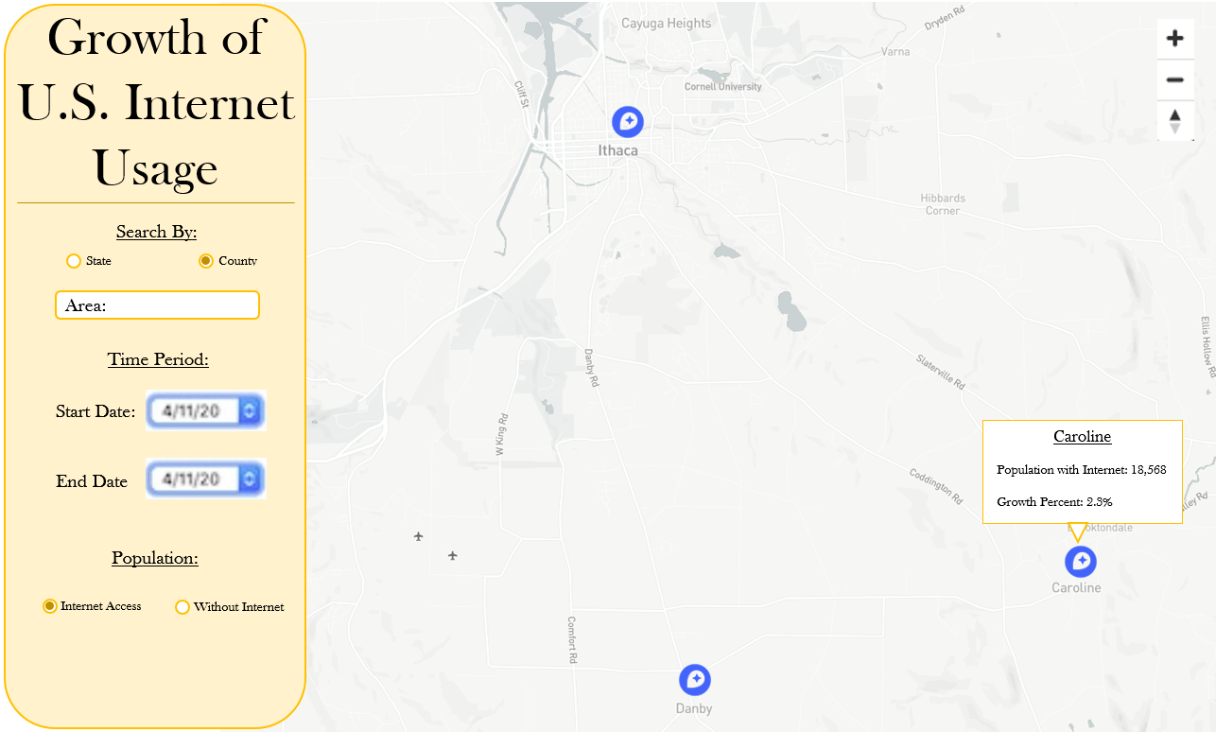

4) I will be working independently.